**

*Positive Behaviour policy & statement of principles*

**Mission Statement**

Botwell House Catholic Primary School is distinguished by the care, courtesy and concern extended to all its members, regardless of cultural differences and strives to follow the teachings of Jesus Christ to:

###### *“Love one another as I have loved you”*

Through a partnership between home, school and parish and through a broad and balanced curriculum, each valued individual is encouraged to grow in their journey of faith and strive towards excellence.

Botwell House Catholic Primary School seeks to ensure that all pupils receive a full-time education which maximises opportunities for each pupil to realise his/her potential.

Current revision: 15.04.25

Date for further revision: 15.04.27

Delegated to: Headteacher

Reviewer: Kevin Oakley

 15.04.25

*(Headteacher) (Date)*

**Contents**

1. Rationale 3

2. Aims 3

3. Legislation and statutory requirements 3

4. Definitions 4

5. Bullying 5

6. Roles and responsibilities 6

7. Communication 7

7.1. Expected Behaviour 7

7.2. Unexpected Behaviour 8

8. Behaviour management 9

8.1 Classroom management 9

8.2 Physical Restraint 9

8.3 Confiscation 10

8.4 Pupil support 10

9. Pupil transition 10

10. Training 10

11. Exclusions 11

12. Monitoring arrangements 12

13. Links with other policies 12

Appendix 1: written statement of behaviour principles 13

Appendix 2: 3:3 Regulation Station

Appendix 3: Zones Tool Worksheet

1. **Rationale**:

Botwell House Catholic Primary School has a positive and inclusive Christian approach to managing behaviour. We believe in encouraging behaviour through a range of positive and pro-active behaviour management strategies. We recognise that behaviour is a demonstration of communicating and expressing emotions.

We believe that by teaching our children how to express their emotions and self-regulate, we are empowering our future community with the ability to communicate emotions through words and not action; show tolerance and empathy; think about consequence and understand the ripple effect of their actions.

1. **Aims**:

We achieve this by infusing a whole school approach throughout the school day and as part of our behaviour curriculum. By embracing and including our families in our approach, we nurture the investment in our pupils emotional well-being by building a strong team around them.

The Zones of Regulation is a visual approach that teaches children how to recognise and self-regulate their emotions in an appropriate or ‘expected’ manner.

By providing a safe and nurturing environment in which our children are taught how to communicate, understand and manage their emotions, we are enabling them to develop their appreciation of Care, Courtesy and Concern which is underpinned by our Lord’s words “Love one another as I have loved you”.

In addition, it is our aim that each child should develop moral values and a code of behaviour based around our virtues supporting each other to treat/love one another as they would like to be treated. We believe that children should be treated fairly, consistently and with their individual needs accounted for, therefore being made to feel valued within our school.

By using this approach, we are able to involve the team around each child by using a shared language and shared strategies. We empower our children, families and staff through the Zones of Regulation by being pro-active in our behaviour management rather than reacting after a crisis has occurred.

Children are taught how to recognise ‘expected’ and ‘unexpected’ behaviours in themselves and others. They are supported with this through restorative discussion that is facilitated, allowing them to reflect upon their own behaviour and consequently build the underpinning skills that are a pre-requisite of self-regulation.

The school’s positive behaviour policy is designed to support the way in which all members of the school can live and work together in a supportive way. It aims to promote an environment where everyone feels happy, safe and secure.

1. **Legislation and statutory requirements**

This policy is based on legislation and advice from the Department for Education (DfE) on:

* [Behaviour and discipline in schools: advice for headteachers and school staff, 2016](https://www.gov.uk/government/publications/behaviour-in-schools--2)
* [Behaviour in schools: advice for headteachers and school staff 2022](https://www.gov.uk/government/publications/behaviour-in-schools--2)
* [Searching, screening and confiscation at school 2018](https://www.gov.uk/government/publications/searching-screening-and-confiscation)
* [Searching, screening and confiscation: advice for schools 2022](https://www.gov.uk/government/publications/searching-screening-and-confiscation)
* [The Equality Act 2010](https://www.gov.uk/government/publications/equality-act-2010-advice-for-schools)
* [Keeping Children Safe in Education](https://www.gov.uk/government/publications/keeping-children-safe-in-education--2)
* [Exclusion from maintained schools, academies and pupil referral units in England 2017](https://www.gov.uk/government/publications/school-exclusion" \l ":~:text=Schools%20and%20colleges%20must%20continue,headteachers)
* [Suspension and permanent exclusion from maintained schools, academies and pupil referral units in England, including pupil movement - 2022](https://www.gov.uk/government/publications/school-exclusion" \l ":~:text=Schools%20and%20colleges%20must%20continue,headteachers)
* [Use of reasonable force in schools](https://www.gov.uk/government/publications/use-of-reasonable-force-in-schools)
* [Supporting pupils with medical conditions at school](https://www.gov.uk/government/publications/supporting-pupils-at-school-with-medical-conditions--3)

It is also based on the [Special Educational Needs and Disability (SEND) Code of Practice](https://www.gov.uk/government/publications/send-code-of-practice-0-to-25).

In addition, this policy is based on:

Section 175 of the [Education Act 2002](http://www.legislation.gov.uk/ukpga/2002/32/section/175), which outlines a school’s duty to safeguard and promote the welfare of its pupils

Sections 88 to 94 of the [Education and Inspections Act 2006](http://www.legislation.gov.uk/ukpga/2006/40/section/88), which requires schools to regulate pupils’ behaviour and publish a behaviour policy and written statement of behaviour principles, and give schools the authority to confiscate pupils’ property

# **Definitions**

**Typical examples of unexpected behaviour** can be defined as:

* Disruption in lessons, in corridors between lessons, and at break and lunchtimes
* Non-completion of classwork or homework
* Poor attitude
* Repeated breaches of the school rules
* Any form of bullying
* Sexual violence and/or harassment,
* Vandalism
* Theft
* Physical altercations
* Smoking
* Racist, sexist, homophobic or discriminatory behaviour
* Threatening behaviour
* Possession of any prohibited items. These are:
* Knives or weapons
* Alcohol
* Illegal drugs
* Stolen items
* Tobacco and cigarette papers
* Vapes
* Fireworks
* Pornographic images
* Any article a staff member reasonably suspects has been, or is likely to be, used to commit an offence, or to cause personal injury to, or damage to the property of, any person (including the pupil)

# **Bullying**

**Bullying** is defined as the repetitive, intentional harming of one person or group by another person or group, where the relationship involves an imbalance of power.

Bullying is, therefore:

* Deliberately hurtful
* Repeated, often over a period of time
* Difficult to defend against

Bullying can include:

|  |  |
| --- | --- |
| **Type of bullying** | **Definition** |
| Emotional | Being unfriendly, excluding, tormenting |
| Physical | Hitting, kicking, pushing, taking another’s belongings, any use of violence |
| Racial | Racial taunts, graffiti, gestures |
| Sexual | Explicit sexual remarks, display of sexual material, sexual gestures, unwanted physical attention, comments about sexual reputation or performance, or inappropriate touching |
| Direct or indirect verbal | Name-calling, sarcasm, spreading rumours, teasing |
| Cyber-bullying | Bullying that takes place online, such as through social networking sites, messaging apps or gaming sites |

Family and staff can report any issues relating to bullying to the child’s class teacher initially. The Class teacher liaises with their team leader or, in their absence, a senior member of staff. A full investigation will take place where accounts are taken from all parties involved in writing where possible with further probing questions by a single investigating officer.

Where a pupil has been found to be bullying another, family involvement will be sought and consequences agreed with the family. A restorative model will be put in place to enable to the pupil to become aware of the impact of their actions on others. Restorative justice work will be undertaken to help sculpt a more purposeful and positive relationship between the children involved.

There will always be follow up work with ongoing monitoring to ensure that further issues do no occur.

# **Discrimination**

Although bullying does not always relate to a protected characteristic, we acknowledge that some acts of bullying do.

The Equality Act 2010, identifies the ‘protected characteristics’ as:

age

disability

gender reassignment

pregnancy and maternity

race

religion or belief

sex

sexual orientation

Where it is agreed that an act of bullying or harassment relates to the protected characteristics:

* The event will be recorded on CPOMS
* Families will be spoken to
* Relevant teaching sessions around the specific characteristic delivered as appropriate

We actively promote diversity and inclusion within our curriculum and work to embed them into our whole school ethos.

# **6.** **Roles and responsibilities**

5.1 The governing board

The Governing Board is responsible for:

* Reviewing and approving the written statement of behaviour principles (appendix 1)
* Being aware and in agreement with this behaviour policy in conjunction with the headteacher
* Monitoring the policy’s effectiveness
* Holding the headteacher to account for its implementation

5.2 The headteacher

The headteacher is responsible for:

* Reviewing this policy in conjunction with the Governing Board.
* Giving due consideration to the school’s statement of behaviour principles (appendix 1)
* Approving this policy
* Ensuring that the school environment encourages positive behaviour
* Ensuring that staff deal effectively with poor behaviour
* Monitoring that the policy is implemented by staff consistently with all groups of pupils
* Ensuring that all staff understand the behavioural expectations and the importance of maintaining them
* Providing new staff with a clear induction into the school’s behavioural culture to ensure they understand its rules and routines, and how best to support all pupils to participate fully
* Offering appropriate training in behaviour management, and the impact of special educational needs and disabilities (SEND) and mental health needs on behaviour, to any staff who require it, so they can fulfil their duties set out in this policy
* Ensuring this policy works alongside the safeguarding policy to offer pupils both sanctions and support when necessary
* Ensuring that the data from the behaviour log is reviewed regularly, to make sure that no groups of pupils are being disproportionately impacted by this policy (see section 13.1)

5.3 Teachers and staff

Staff are responsible for:

* Creating a calm and safe environment for pupils that reflects the Zones of Regulation approach
* Establishing and maintaining clear boundaries of acceptable pupil behaviour
* Implementing the behaviour policy consistently
* Communicating the school’s expectations, routines, values and standards through teaching behaviour and in every interaction with pupils
* Modelling expected behaviour and positive relationships
* Providing a personalised approach to the specific behavioural needs of particular pupils
* Considering their own behaviour on the school culture and how they can uphold school rules and expectations
* Recording behaviour incidents promptly
* Challenging pupils to meet the school’s expectations

The senior leadership team (SLT) will support staff in responding to behaviour incidents.

5.4 Family and carers

Family and carers, where possible, should:

* Get to know the school’s behaviour policy and reinforce it at home where appropriate
* Support their child in adhering to the school’s behaviour policy
* Inform the school of any changes in circumstances that may affect their child’s behaviour
* Discuss any behavioural concerns with the class teacher promptly
* Take part in any pastoral work following misbehaviour (for example: attending reviews of specific behaviour interventions)
* Raise any concerns about the management of behaviour with the school directly, whilst continuing to work in partnership with the school
* Take part in the life of the school and its culture

The school will endeavour to build a positive relationship with family and carers by keeping them informed about developments in their child's behaviour and the school’s policy, and working in collaboration with them to tackle behavioural issues.

 5.5 Pupils

Pupils will be made aware of the following during their induction into the behaviour culture:

* The expected standard of behaviour they should be displaying at school and what is meant by ‘expected’ and ‘unexpected’ behaviour
* That they have a duty to follow the behaviour policy
* The school’s key rules and routines
* The rewards they can earn for meeting the behaviour standard, and the consequences they will face if they don’t meet the standard
* The pastoral support that is available to them to help them meet the behavioural standards

Pupils will be supported to meet the behaviour standards and will be provided with repeated induction sessions wherever appropriate.

Pupils will be supported to develop an understanding of the school’s behaviour policy and wider culture.

Pupils will be asked to give feedback on their experience of the behaviour culture to support the evaluation, improvement and implementation of the behaviour policy.

Extra support and induction will be provided for pupils who are mid-phase arrivals.

# **7.** **Communication**

Throughout the school, all adults will use the same language when talking about behaviour and emotions, using the terms ‘expected’ and ‘unexpected’ when describing a behaviour.

Children displaying ‘expected’ behaviour whereby they are working through emotions appropriately, trying their hardest and demonstrating behaviours linked to the virtues are praised accordingly.

Children displaying an ‘unexpected’ behaviour have a stepped approach in order to give the opportunity for reflection. Please See the ‘Unexpected Behaviour’ Section below

**7.1 Expected Behaviour**

### Children are praised and rewarded whenever possible in a variety of ways:

The most common reward is praise, informal and formal, public and private, to individuals and groups. Children will be taught that there are positive consequences for following school rules and displaying ‘expected’ behaviour and that there will be negative consequences for breaking the rules and displaying ‘unexpected’ behaviour. Individual teacher’s reward children and praise good effort and behaviour through; verbal praise, positive comments on work, celebration of efforts through display.

**Assemblies**

Every term the Key stages/phases comes together for a celebration assembly. We take time as a school to celebrate each other’s success, these can be from home or within school. It is an important time for the children to come together and be proud of each other.

**House Points**

All staff award house points including T.As, SMSAs, the admin team, cleaners and the caretaker. House points are introduced at the end of the summer term for Reception children as part of their transition into year 1.

Generally, staff can give out between 1-3 HPs

Leadership team can give up to 5 HPs

The Headteacher can give up to 10HP for those really outstanding scenarios.

To support staff outside of the classroom, tokens will be made available to give to children that are displaying positive behaviours in the corridors and shared spaces. The token will be handed to the child to be given to the class teacher. This will be exchanged for a HP on DOJO.

At the end of each term, there will be a special reward given to a child from any year group who has shown improved behaviour throughout the term which should reflect their house points from the beginning and end of term.

There will also be another award given to the child who has got the most HPs that term.

Also, at the end of each term, the House which has gained the most house points that term, will be given a special whole school treat. The Leadership Team will decide the treat each term.

**Star of the Week**

Every Friday morning ‘Star of the Week’ a certificate is awarded for attitude and effort towards their academic work. The child receives a certificate to take home.

**Following C.H.R.I.S.T award**

Every week, the children focus on a specific virtue and endeavour to demonstrate that in their behaviour and interactions with the school community. All classes focus on this virtue to help the children link the positive behaviours and traits to Christs words and actions.

Line of the week award

This is a new award to support the children with how effectively they line up and return to class. Each phase will have a winner announced in assembly on Fridays. The team leaders will liaise with the staff that are involved with their children to decide who the winning class is. A certificate is presented to the winning class by one of the team leaders. It is important to note that this is to empower all staff at break/lunch times but particularly the SMSA.

**Headteacher’s Award**

A special head teacher’s award can also be given for a particular achievement or act of character

**7.2 Unexpected Behaviour**

Children know the consequences of unexpected behaviour. All staff in the school follow the same steps using the Zones of Regulation approach (Reception follows this from the summer term,) to ensure fairness and consistency, whilst further supporting transition between year groups.

Children are reminded of expected behaviours via the Zones of Regulation approach throughout the school day.

Children are given the opportunity to communicate and discuss unexpected behaviour by using the restorative model with a familiar adult. They are also encouraged to visit the ‘Regulation Station’ so that they are able to use tools that help them to de-escalate to a calm state.

Our families are asked to share this approach at home. We support our families in this by providing Zones of Regulation family training and empower them with the tools and language necessary to achieve maximum success.

This is the stepped approach staff will use for children displaying unexpected behaviour:

**KS1**

See (appendix 4) which will be displayed in the classroom with the pupil’s peg names around it.

If a pupil is displaying ‘unexpected’ behaviour peg gets moved across from expected to ‘Unexpected’.

If this behaviour continues, again, the peg is moved to ‘continued Unexpected Behaviour’.

If the behaviour does not improve, their name is moved to the ‘Consequence’.

KS1 Consequence – The pupil will miss 2 minutes of their next playtime to reflect on their behaviour with the adult who they were with. Alternatively, they can catch up with missed learning during the lesson.

If at any point they improve their behaviour during this process before reaching the consequence, the teacher should move their peg to reflect this.

**KS2**

See (appendix 5) which will be displayed on every individual table.

If a pupil is displaying ‘unexpected’ behaviour staff should put an ‘X’ in the ‘**I need to think and fix it’** box.

If this behaviour continues, again, staff should decide if they need to **Practise (P)** or need **Reflection (R)** time. See Appendix 5 for more detail.

If the behaviour is more serious the children should be moved to **Consequence (C).** SLT are to get involved and parents must be informed.

**SLT involvement:**

**Serious Incidents**

-In the event of a serious behavioural incident occurring, (see list below) a teacher will send for a member of SLT to come and take the individual(s) for the remainder of the day.

If there are no other adults available, the teacher will send 2 children to the SLT room with an ‘SLT Request’ card to signify needing an SLT member.

This behaviour includes:

* Kicking or hitting another child or adult with the intent to harm them.
* Use of swear words directed at a person.
* Threats of violence to another person – spoken or physically displayed.
* Refusal to co-operate with an adult’s instructions after the behaviour system has been utilised.

**Persistent Behaviour**

If any pupil is needing to Practise or Reflect more than twice within a week, on the third occasion a **Consequence (C)** is given. SLT are to get involved and parents must be informed.

In the event of persistent behaviour, SLT will arrange for the child to have a prolonged period of reflection, enabling coaching and restorative conversations to help the child to correct their behaviours long term. This will either be at lunchtime or throughout the day depending on the situation.

**Suspensions and Exclusions**

Suspension or even exclusion from school are the ultimate sanctions in the chain of disciplinary measures. These measures would be considered in serious cases such as extreme violence, major bullying incidents, severe destructive behaviour or a child swearing at or hitting a teacher.

Where efforts using strategies within the year group are ineffective, at this point, a senior leader is involved.

The school will seek advice from the LBH Participation Team if they have concerns regarding a child’s behaviour, and try and seek support and advice when a child is at risk of exclusion in order to avoid this eventuality.

The initial decision to exclude a child can only be taken by the Headteacher. The family of the pupil is informed in writing of the suspension, its length and the reason for it. They are also informed of their right to appeal to the Governing Board. The Chair is informed. All this is done on standardised documentation.

It is acknowledged by the school that many children may have particular emotional, social, medical or learning difficulties/needs which may, contribute to them displaying challenging behaviour. In such cases, the school aims to work with family and other professionals to ascertain the problem, attempt to understand it, and put together targets for improvement and ways of achieving these targets. The Inclusion Manager and class teacher will do this during regular discussions.

The Inclusion Manager may decide to inform outside agencies such as the educational psychologist or CAMHS etc. A behaviour Plan may also be used to monitor behaviour closely each term.

In some instances, calling a support meeting, which is attended by multi-professionals can offer positive and practical support and guidance for the pupil, family and the school.

# **8.** **Behaviour Management**

**8.1 Classroom management**

Teaching and support staff are responsible for setting the tone and context for positive and expected behaviour within the classroom.

Staff will:

* Consistently follow and model procedures set out in section 7.2
* Display whole school rules adding bespoke class-specific rules that are devised with the children
* Create a ‘Regulation Station’ as per Zones of Regulation Guidance
* Create and maintain a stimulating environment that encourages pupils to be engaged
* Use the shared language associated with the Zones of Regulation
* Use the restorative method to discuss any unexpected behaviour
* Develop a positive relationship with pupils, which may include:
  + Greeting pupils in the morning/at the start of lessons
  + Establishing clear routines
  + Highlighting and promoting good behaviour
  + Concluding the lesson positively and starting the next afresh
  + Pre-empting when pupils are going to struggle; adapting to their needs through personalised support and positive reinforcement

**8.2 Physical restraint**

In some circumstances, trained staff may use reasonable force in line with physical restraint guidance to restrain a pupil to prevent them:

* Causing disorder
* Hurting themselves or others
* Damaging property

Incidents of physical restraint must:

* Always be used as a last resort following every effort to de-escalate
* Be applied using the minimum amount of force and for the minimum amount of time possible
* Be used in a way that maintains the safety and dignity of all concerned
* Never be used as a form of punishment
* Be recorded and reported to family

Where appropriate the above must follow the guidance as laid out in the child’s individual personal behaviour plan.

**8.3 Confiscation**

**Any prohibited items (listed in section 3) found in pupils’ possession will be confiscated.** These items will not be returned to pupils.

We will also confiscate any item which is harmful or detrimental to school discipline. These items will be returned to pupil’s family after discussion with senior leaders, if appropriate.

Searching and screening pupils is conducted in line with the DfE’s [latest guidance on searching, screening and confiscation](https://www.gov.uk/government/publications/searching-screening-and-confiscation).

* 1. **Pupil support**

The school recognises its legal duty under the Equality Act 2010 to prevent pupils with a protected characteristic from being at a disadvantage. Consequently, our approach to challenging behaviour may be differentiated to cater to the needs of the pupil.

The school’s Inclusion Manager will evaluate a pupil who exhibits challenging behaviour to determine whether they have any underlying needs that are not currently being met.

Where necessary, support and advice will also be sought from specialist teachers, an educational psychologist, medical practitioners and/or others, to identify or support specific needs.

When acute needs are identified in a pupil, we will liaise with external agencies and plan support programmes for that child. We will work with the family to co-create the plan and review it on a regular basis.

# **9. Pupil Transition**

To ensure a smooth transition to the next year, pupils have transition days with their new teacher. In addition, staff members hold transition meetings.

To ensure behaviour is continually monitored and the right support is in place, information related to pupil behaviour issues may be transferred to relevant staff at the start of the term or year. Information on behaviour issues may also be shared with new settings for those pupils transferring to other schools.

# **10. Training**

Our staff are provided with training on Zones of Regulation as part of their induction process. The behaviour policy is also shared with them. Behaviour management will also form part of continuing professional development but is a starting point every academic year to identify school behaviour priorities.

# **13. Monitoring Arrangements**

This behaviour policy will be reviewed by the headteacher and shared with the Full Governing Board every year. The policy is not statutory for the FGB but the principles (appendix 1) and suspension/exclusion arrangements are and as such the policy will be treated like this too.

# **14. Links with other policies**

This behaviour policy is linked to the following policies:

* Child Protection and Safeguarding policy
* Local offer
* Online Safety policy
* Drug and alcohol policy
* SEN/D policy

# Appendix 1: written statement of behaviour principles

* Every pupil understands they have the right to feel safe, valued and respected, and learn free from the disruption of others
* All pupils, staff and visitors are free from any form of discrimination
* Staff and volunteers set an excellent proactive example to pupils at all times befitting our faith and our journey as ethical leaders.
* Rewards, sanctions and reasonable force are used consistently by staff, in line with the behaviour policy
* The positive behaviour policy is understood by pupils and staff
* The exclusions policy (included within the behaviour policy) explains that exclusions will only be used as a last resort, and outlines the processes involved in suspensions and exclusions
* Pupils are helped to take responsibility for their actions
* Families are involved in behaviour incidents to foster good relationships between the school and pupils’ home life

The governing board also emphasises that violence or threatening behaviour will not be tolerated in any circumstances.

This written statement of behaviour principles is reviewed and approved by the Full Governing Board annually.

# Appendix 1: Example of a regulation station

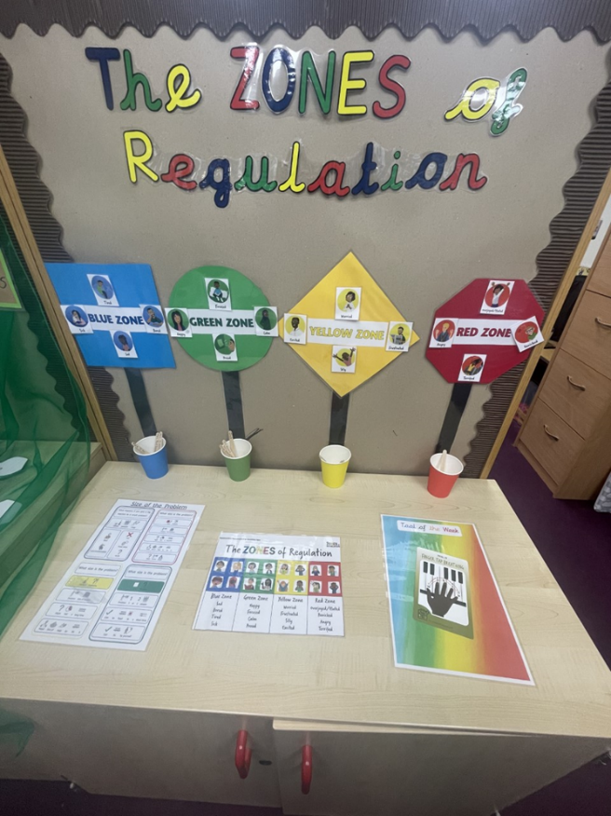

# Appendix 2: Zones Tool Worksheet

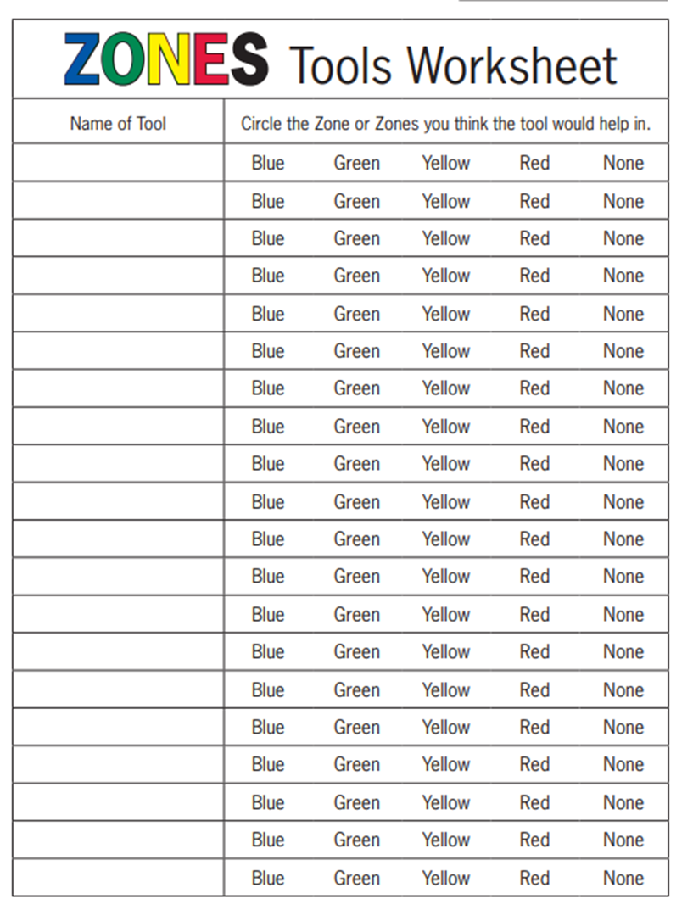

# Appendix 3: KS1 Behaviour chart

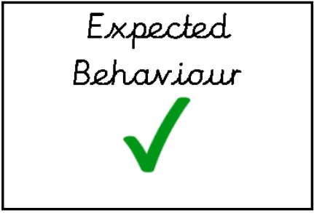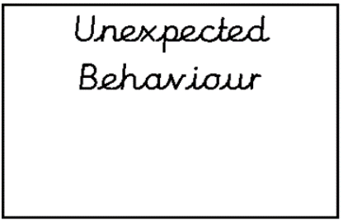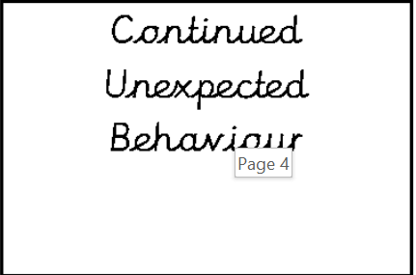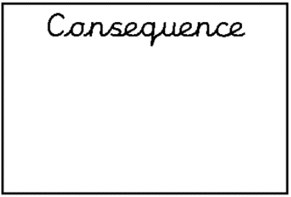

# Appendix 4: KS2 Behaviour chart

|  |  |  |
| --- | --- | --- |
| Expected Behaviour |  | Unexpected Behaviour |
| I am making the right choices | I need to think and fix it | I need a:  -Practise (P)  -Reflection (R)  -Consequence (C) |
| √ |  |  |

**Practise** means the children will stay in to practise what they intentionally choose not to do correctly within the lesson.

**Reflection** means they will stay in to reflect on disrespect show within the lesson. Reflection sheet needs to be completed.

**Consequence** is used for more serious behaviour. SLT should be involved and parents are to be contacted.

An X is written subtly by you or by the child. They have an opportunity to make better choices. Once they’ve shown they are trying to make better choices – you are to remove the X

# Appendix 5: KS2 Reflection Sheet

Botwell House Catholic Primary School

Behaviour Reflection Sheet

What did I choose to do?

|  |
| --- |
|  |
|  |
|  |

Why did I make this choice?

|  |
| --- |
|  |
|  |
|  |

Who did my choices affect?

|  |
| --- |
|  |
|  |
|  |

How did they feel because of my choices?

|  |
| --- |
|  |
|  |
|  |

Which of our school virtues was I not showing by making this choice?

|  |  |  |  |  |  |
| --- | --- | --- | --- | --- | --- |
| community | happiness | resilience | integrity | sacredness | togetherness |
| respect | responsibility | perseverance | obedience | self-discipline | cooperation |
| friendliness | listening | courage | diligence | courtesy | patience |
| gentleness | cleanliness | assertiveness | honesty | peacefulness | unity |

Have I apologised to the people affected?

|  |
| --- |
|  |

What will I do differently next time?

|  |
| --- |
|  |
|  |

Signed:

Pupil: ____________________ Parent: ____________________ Teacher: ____________________

**Please return the signed sheet to your class teacher.**

# KS1 Reflection Sheet

Botwell House Catholic Primary School

Behaviour Reflection Sheet

What did I choose to do?

|  |  |
| --- | --- |
| I hurt someone. | I used unkind words. |
| I refused an adult. | I was not listening. |
| Other: | |

Why did I make this choice?

|  |
| --- |
|  |

Who did my choices affect?

|  |  |
| --- | --- |
| Another child | An adult |
| My class | Me |

How did they feel because of my choices?

|  |
| --- |
|  |

Which of our school virtues was I not showing by making this choice?

|  |  |  |
| --- | --- | --- |
| care | courtesy | concern |

Have I apologised to the people affected?

|  |
| --- |
|  |

What will I do differently next time?

|  |
| --- |
|  |

Signed:

Pupil: ____________________ Parent: ____________________ Teacher: ____________________

**Please return the signed sheet to your class teacher.**